1️⃣ Introduction to Classification
What is Classification?
Classification is a supervised machine learning task where:
- Target variable is categorical
- Model predicts class labels
Examples
Problem | Input | Output
Spam Detection | Email text | Spam / Not Spam
Disease Prediction | Medical data | Yes / No
Customer Churn | Customer behavior | Churn / Not Churn
Image Recognition | Pixels | Cat / Dog

Types of Classification
1️⃣ Binary Classification
- Two classes
- Examples:
  - Yes / No
  - 0 / 1
  - True / False
Logistic Regression is mainly used here

2️⃣ Multi-Class Classification
- More than two classes
- Examples:
  - Digit recognition (0–9)
  - Product category classification
Algorithms:
- Softmax Regression
- Decision Trees
- Random Forest
- XGBoost

3️⃣ Multi-Label Classification
- One input → multiple labels
- Example:
  - Movie genre prediction (Action + Comedy)

Classification vs Regression
Aspect | Regression | Classification
Target | Continuous | Categorical
Output | Number | Class / Probability
Example | House price | Spam detection
Loss | MSE | Log Loss

2️⃣ Why Not Use Linear Regression for Classification?
If we use Linear Regression:
- Output can be < 0 or > 1
- No probability interpretation
- Sensitive to outliers
- Poor decision boundary
👉 Solution: Use Logistic Regression

3️⃣ Logistic Regression – Core Idea
Despite the name, Logistic Regression is a classification algorithm.
What does it do?
- Predicts probability of a class
- Converts probability → class label using a threshold

Logistic Regression Equation
Step 1: Linear Combination
Same as linear regression:
$$z=w_{0}+w_{1}x_{1}+w_{2}x_{2}+...+w_{n}x_{n}$$

Step 2: Sigmoid Function
Logistic Regression applies Sigmoid:
$$σ(z)=\frac{1}{1+e^{-z}}$$
Why Sigmoid?
- Output range: 0 to 1
- Can be interpreted as probability
📉 Sigmoid Curve:
- Large negative z → 0
- Large positive z → 1

Final Prediction Rule
$$\hat{y}=\left\{\begin{matrix}1 & \text{if }P(y=1)≥0.5 \\ 0 & \text{if }P(y=1)<0.5\end{matrix}\right.$$

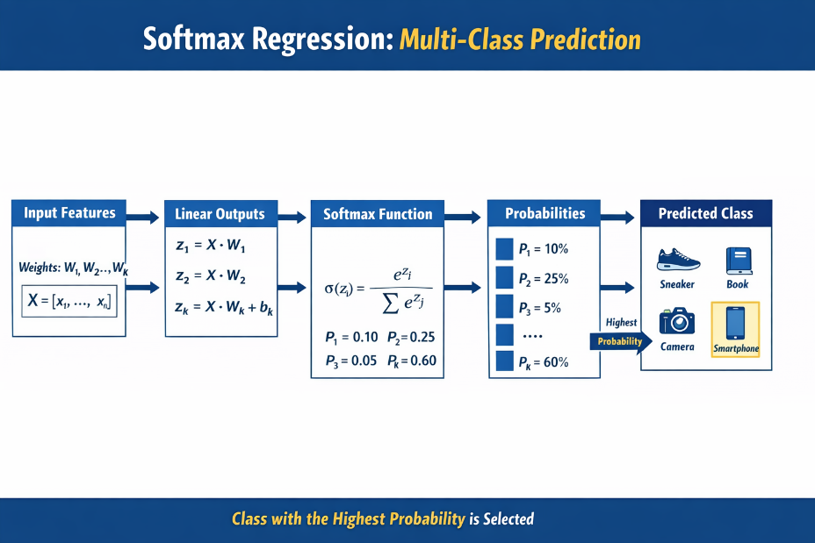
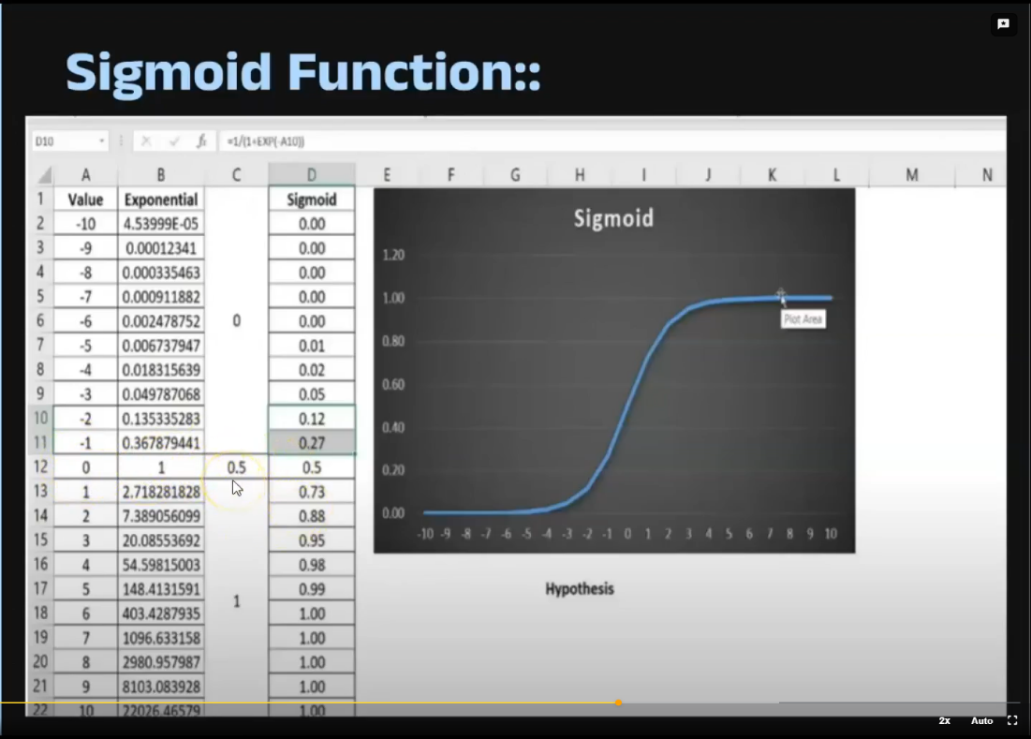

Threshold can be adjusted (0.3, 0.7, etc.)

4️⃣ Logistic Regression – Intuition
Think of Logistic Regression as:
“Drawing a decision boundary that separates two classes using probability.”

5️⃣ Cost Function (Loss Function)
Logistic Regression does NOT use MSE
Why?
- Sigmoid + MSE → non-convex loss
- Hard to optimize

Log Loss / Binary Cross-Entropy
$$\text{Loss}=-[ylog⁡(p)+(1-y)log⁡(1-p)]$$
Interpretation:
- If actual = 1 and prediction is low → huge penalty
- Encourages confident and correct predictions

6️⃣ Model Training – Gradient Descent
Logistic Regression finds optimal weights by minimizing Log Loss using:
- Gradient Descent
- Variants: SGD, Mini-Batch GD

Evaluation Metrics for Classification
Accuracy is NOT enough (especially for imbalanced data).
Common Metrics
Metric | Meaning
Accuracy | Overall correctness
Precision | How many predicted positives are correct
Recall | How many actual positives are captured
F1-Score | Balance of precision & recall
ROC-AUC | Probability ranking quality
Confusion Matrix | Error breakdown

Confusion Matrix
Actual \ Predicted | Positive | Negative
Positive | TP | FN
Negative | FP | TN

A Confusion Matrix is a table used to evaluate the performance of a classification model, especially in binary classification (like Logistic Regression).

1️⃣ What is a Confusion Matrix?
It compares:
- Actual values (ground truth)
- Predicted values (model output)
For binary classification, it’s a 2 × 2 matrix.

2️⃣ Confusion Matrix Structure
 | Predicted: Positive (1) | Predicted: Negative (0)
Actual: Positive (1) | True Positive (TP) | False Negative (FN)
Actual: Negative (0) | False Positive (FP) | True Negative (TN)

3️⃣ Meaning of Each Term
✅ True Positive (TP)
- Model predicts Positive
- Actual is Positive
- ✔️ Correct prediction
Example:
Water is potable → Model predicts potable

❌ False Positive (FP) (Type-I Error)
- Model predicts Positive
- Actual is Negative
Example:
Water is not potable, but model says potable ⚠️
➡️ Dangerous in real life

❌ False Negative (FN) (Type-II Error)
- Model predicts Negative
- Actual is Positive
Example:
Water is potable, but model says not potable

✅ True Negative (TN)
- Model predicts Negative
- Actual is Negative
- ✔️ Correct rejection

4️⃣ Visual Example (Water Potability)
Suppose after prediction:
 | Predicted Potable | Predicted Not Potable
Actual Potable | 80 (TP) | 20 (FN)
Actual Not Potable | 10 (FP) | 90 (TN)

5️⃣ Metrics Derived from Confusion Matrix
All major evaluation metrics come from this matrix 👇

🎯 Accuracy
Overall correctness
$$Accuracy=\frac{TP+TN}{TP+FP+FN+TN}$$

🎯 Precision
Of all predicted positives, how many are actually positive?
$$Precision=\frac{TP}{TP+FP}$$
⚠️ Important when False Positives are costly

🎯 Recall (Sensitivity / True Positive Rate)
Of all actual positives, how many did we catch?
$$Recall=\frac{TP}{TP+FN}$$
⚠️ Important when False Negatives are costly

🎯 F1 Score
Balance between Precision and Recall
$$F1=2×\frac{Precision×Recall}{Precision+Recall}$$

6️⃣ When Confusion Matrix Is More Important Than Accuracy
Accuracy can be misleading in imbalanced datasets.
Example:
- 95% water samples are not potable
- Model predicts always not potable
➡️ Accuracy = 95%
➡️ But model is useless
✔️ Confusion Matrix exposes this problem clearly.

Logistic Regression Assumptions
1️⃣ Binary outcome
2️⃣ Independent observations
3️⃣ No multicollinearity
4️⃣ Linear relationship between features and log-odds
5️⃣ Large sample size preferred

Regularization in Logistic Regression
Prevents overfitting.
L1 (Lasso)
- Feature selection

L2 (Ridge)
- Shrinks coefficients

